COURSE CODE & NAME: ECE1408- EMEBEDDED SYSTEM
NAME: AADARSHIKA K
ROLL NO: 192565081

EX NO: 10
MODELING CLOCK-DRIVEN CONCURRENT PROCESSES USING SC_THREAD AND wait() IN SYSTEMC
1. Aim
To model and simulate clock-driven concurrent processes using SC_THREAD and wait() in SystemC and observe process execution at different simulation times.
2. Software and Hardware Requirements
Software:
- SystemC library
- C++ compiler
- Visual Studio Code or any suitable C++ development environment
Hardware Requirements:
- Computer or laptop
3. Program code:
#include<systemc.h>
SC_MODULE(ClockExample) {
sc_in<bool>clk;
voidprocess() {
while (true) {
wait();
std::cout<<"Time: "<<sc_time_stamp()
<<" - Clock Triggered"<< std::endl;}
}
SC_CTOR(ClockExample) {
SC_THREAD(process);
sensitive<<clk.pos();}
};
intsc_main(intargc, char* argv[]) {
sc_clockclock("clock", 1, SC_NS);
ClockExample module("module");
module.clk(clock);
sc_start(5, SC_NS);
return0;
}
4. OUTPUT:
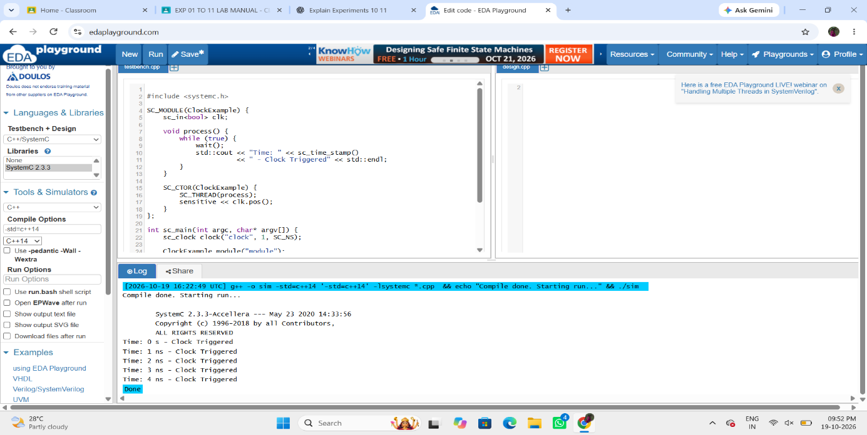

5. Result
Thus, clock-driven concurrent processes were modeled and simulated using SC_THREAD and wait() in SystemC. The execution of the process was observed at different simulation times, demonstrating concurrent process behavior in SystemC.

